Chapter 17, Solution 37.

We first need to express i_{s} in Fourier series. 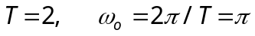

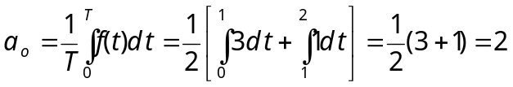

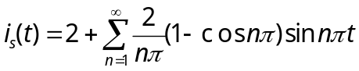

By current division,

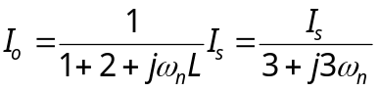
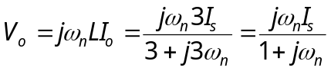
For dc component (n=0), V_{o} = 0.
For the nth harmonic,

